DIE# 15028 – ATI (EXTRUDER SIDE)
Green Buggy – Long Arm – Wrap arms in cardboard
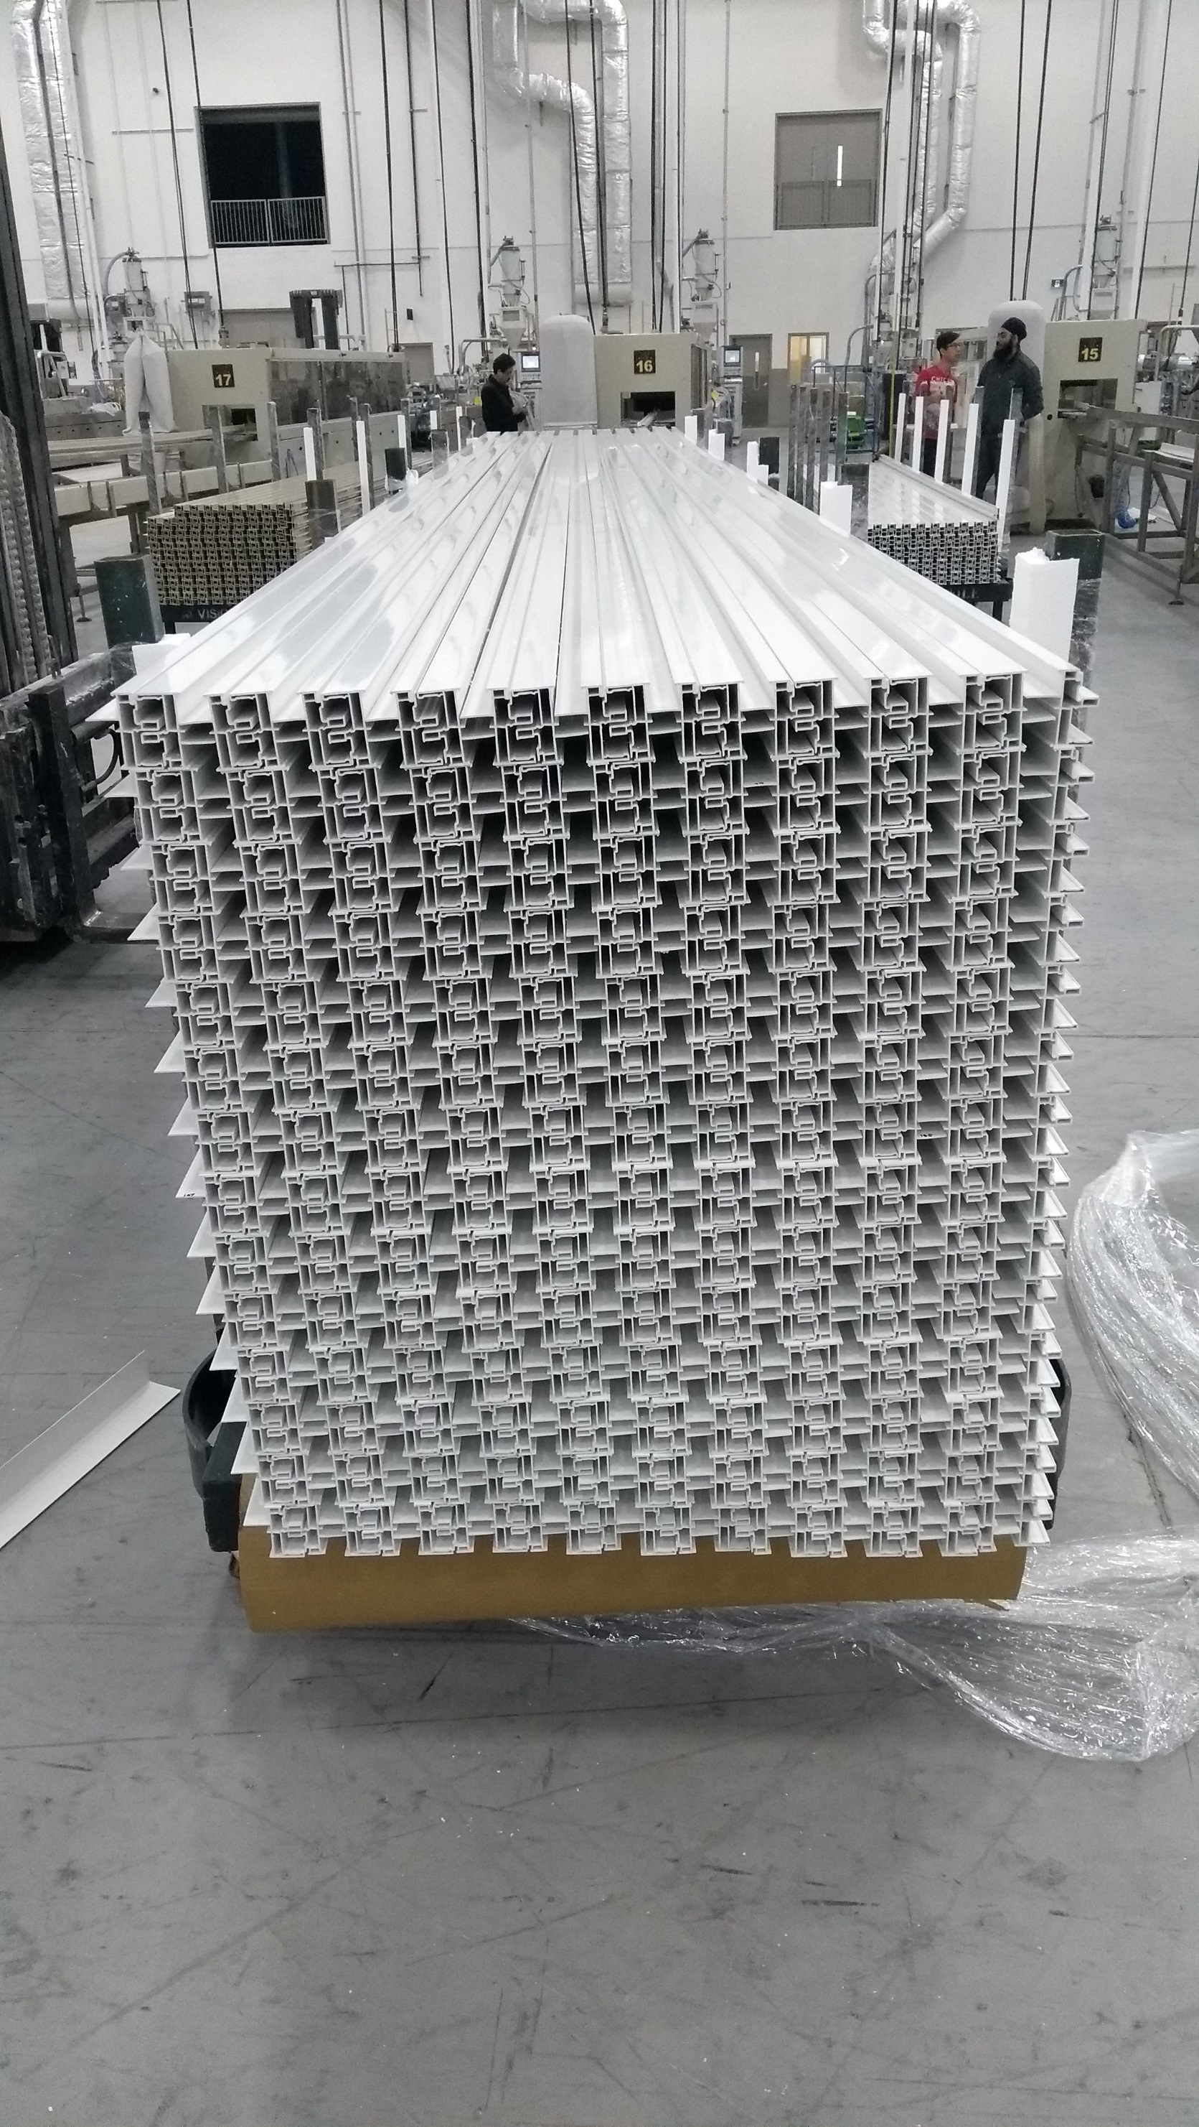
Small Foam on 2 Sides

